**C++ : Conditionals Assignment Solutions**

**1) Find the output for this code. Let input:- 2 3 6**

#include<iostream>

using namespace std;

int main()

{

    int x;

    cout<<"Enter First Number\n";

    cin>>x;//user will give 'x' value.

    int y,m;

    cout<<"Enter second number and value for taking modulus\n";

    cin >> y >> m;//user will give 'x' a value.

    int Z= (x*y)%m;

    cout<<"Output is: " << Z;

    }

**Output**

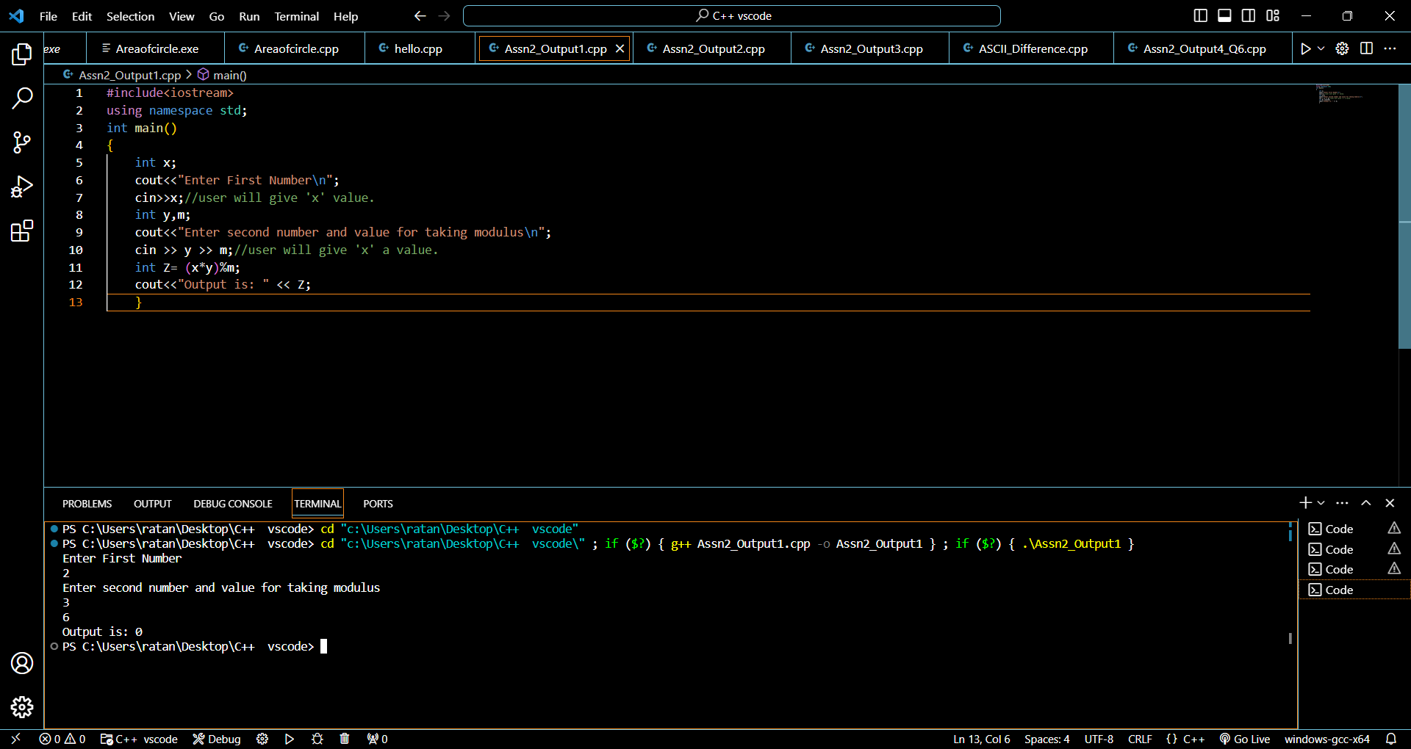

**2) Find the output for this code. Let input:- 3 2**

#include<iostream>

using namespace std;

int main()

{

    int x;

    cout<<"Enter the first number\n";

    cin>>x;

    int y;

    cout<<"Enter second number\n";

    cin >>y; //

    cout<<(x!=y)<<" "<<(x>=y);

}

**Output**

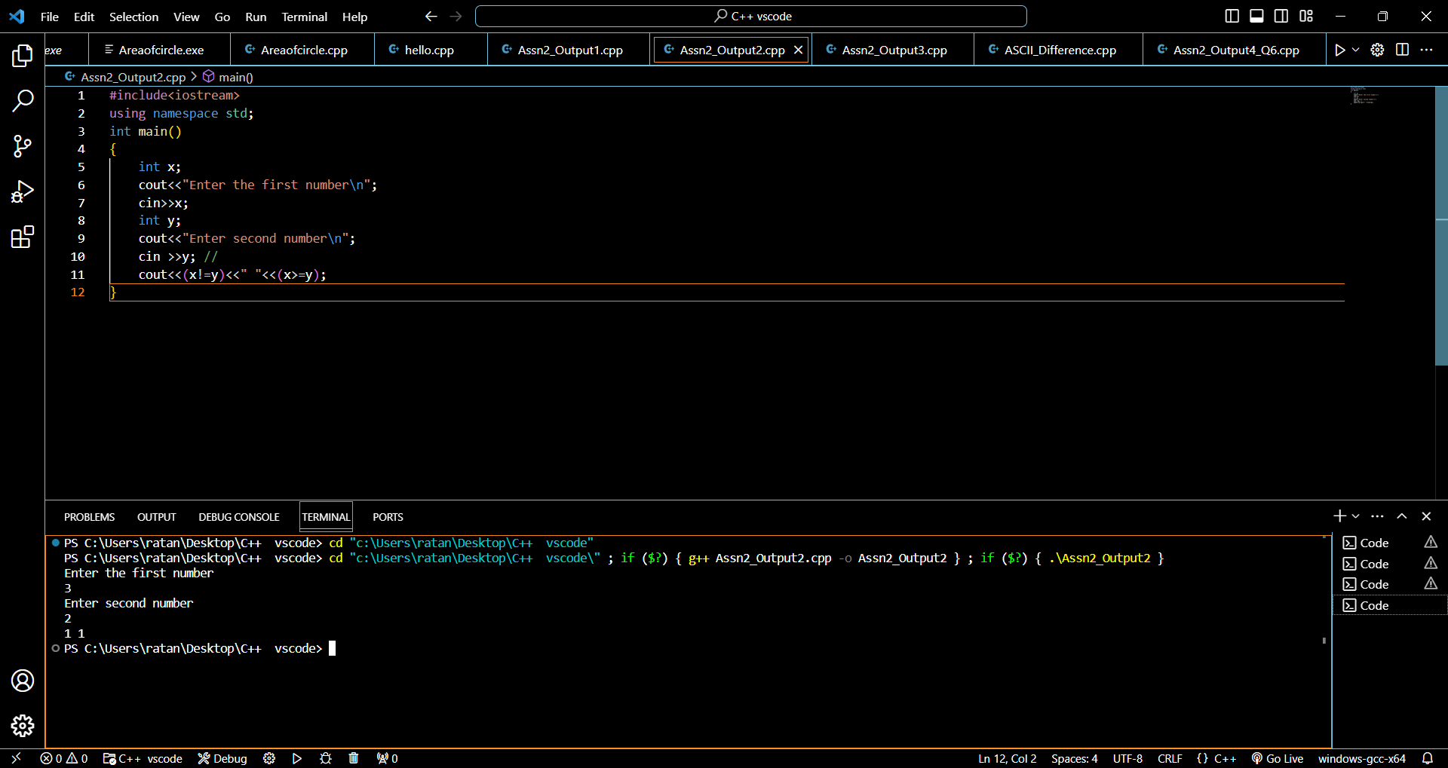

**3) Find the output for this code. Let input:- 2 3**

#include<iostream>

using namespace std;

int main()

{

    int x,y;

    cin >> x >>y;

    x+=y;

    x-=y;

    x%y;

    cout<<x;

}

**Output**

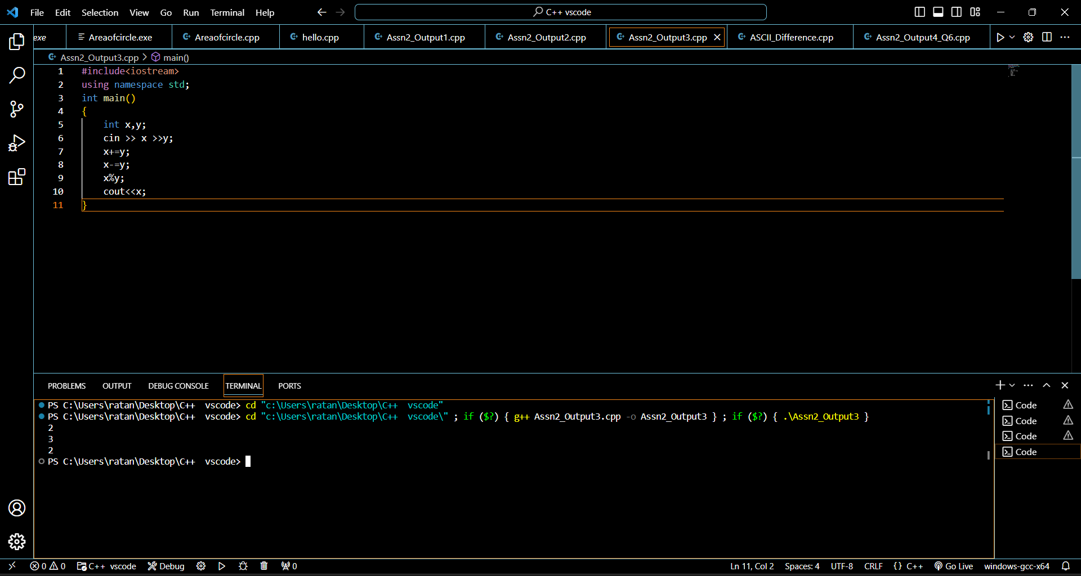

**4) WAP for finding the volume of the cylinder by taking radius and height as input.**

#include<iostream>

using namespace std;

int main()

{

    float radius;

    float height;

    cout<<"Enter the Radius and Height of Cylinder";

    cin>>radius>>height;

    float Area = 3.14 * radius * radius * height;

    cout << "The volume of Cylinder is : "<< Area ;

}

**Output**

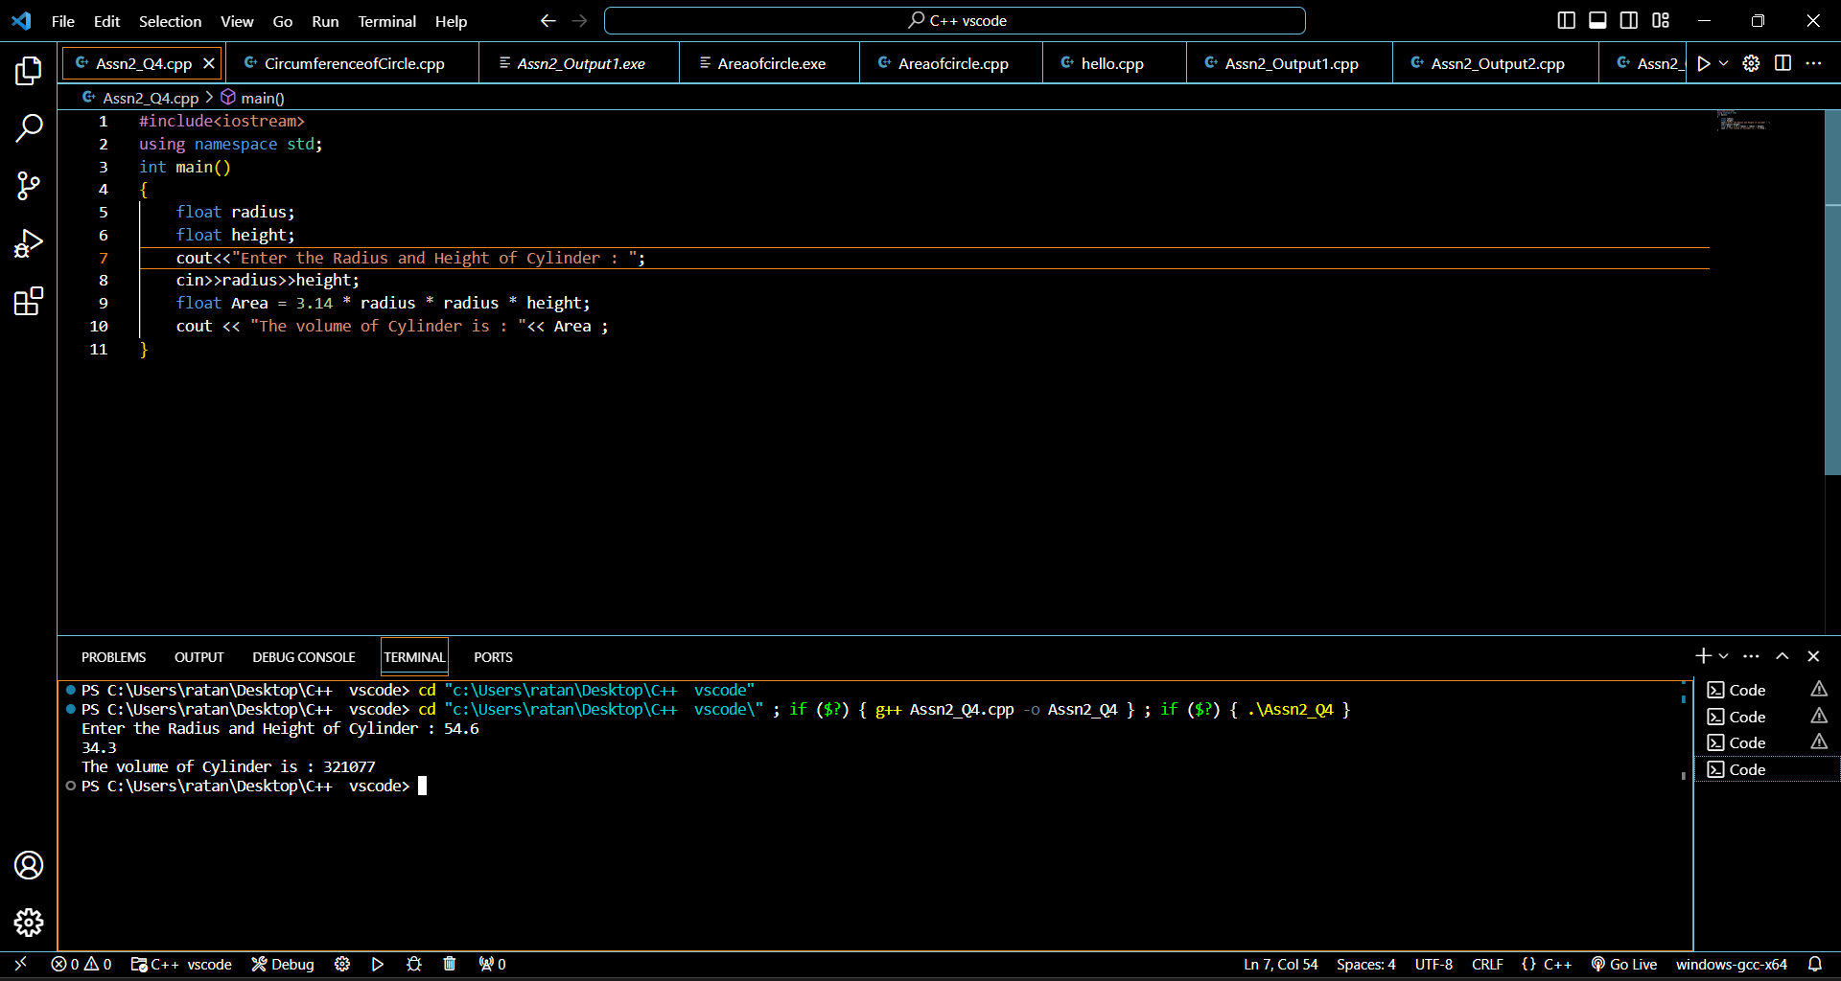

**5) WAP to find the difference between ASCII of two characters, take them as input .**

#include<iostream>

using namespace std;

int main()

{

    char ch1 ;

    char ch2 ;

    cin>>ch1>>ch2 ;

    char c1 = int(ch1);

    char c2 = int(ch2);

    int diff = c1 - c2;

    cout << diff <<endl;

}

**Output**

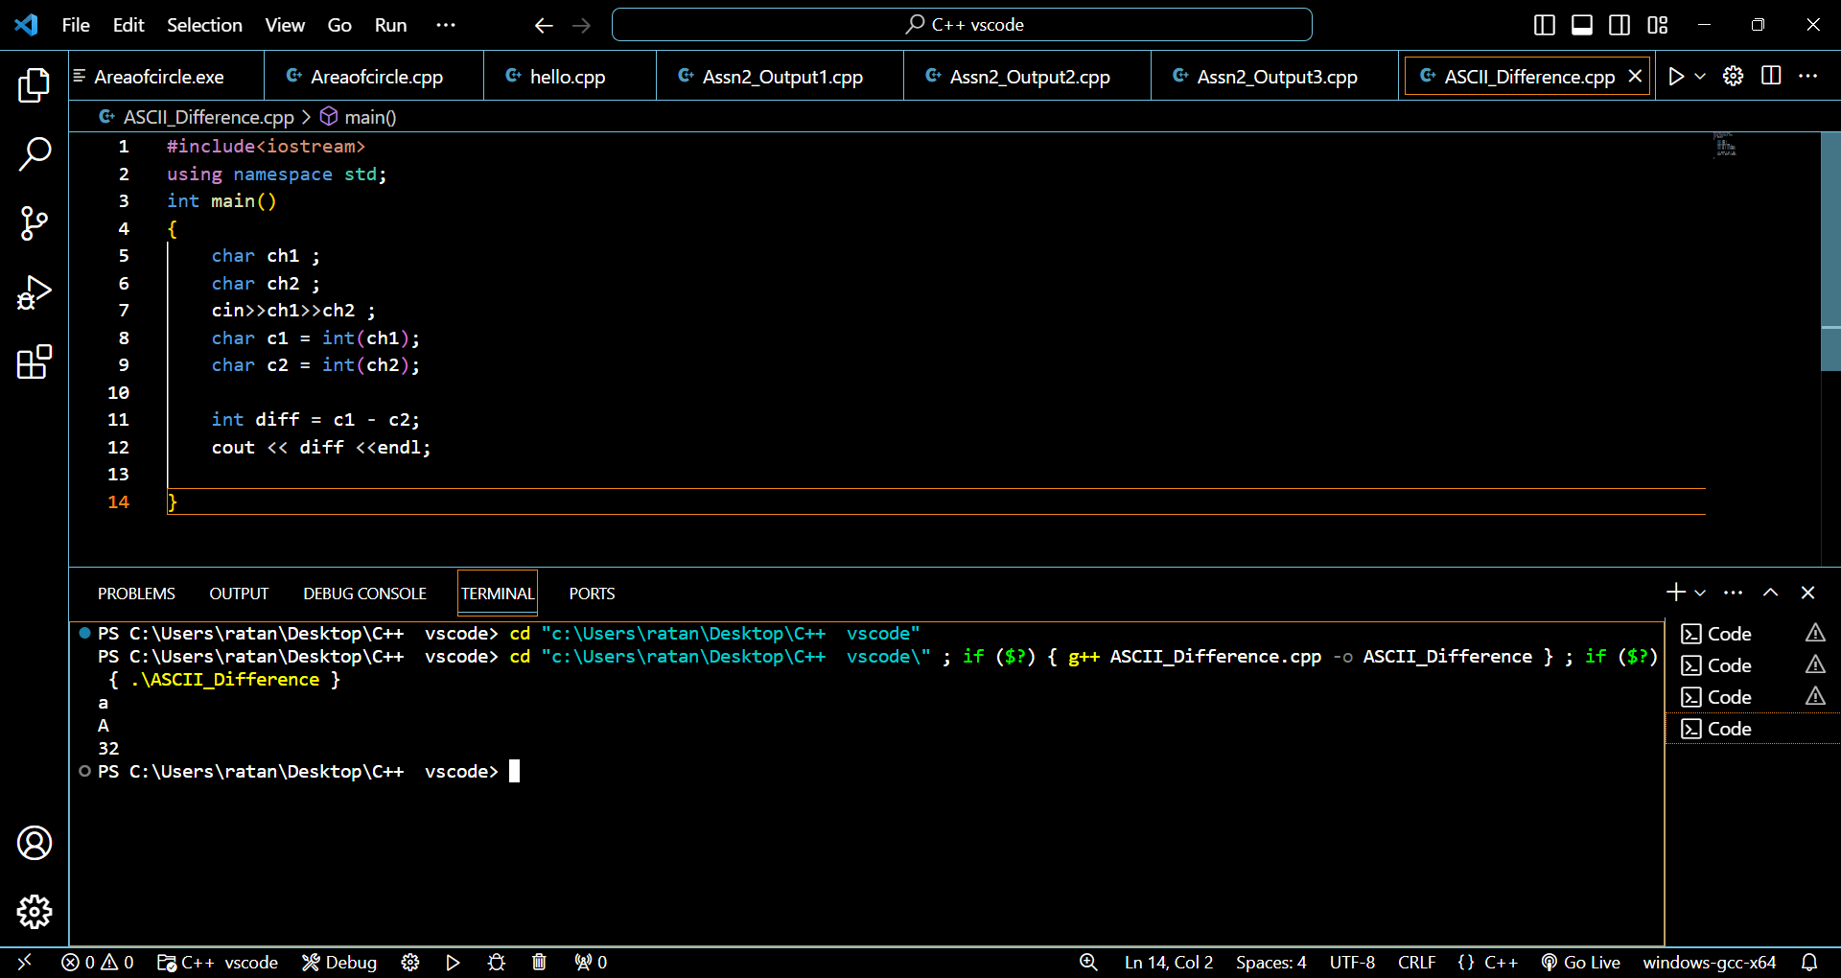

**6) Find the output of the below code**

#include<iostream>

using namespace std;

int main()

{

    int i = (4+7/5*6*6+9)%100;

    cout << i;

}

**Output**

